Gabriella Perez-Hernandez
Prof. Wolf-Powers
URBS 402
20 May 2022
The Aftereffects of the Jerome Avenue Rezoning & Possible Policy Solutions:
Podcast Script
Introduction
Jerome Avenue is a bustling commercial and transit corridor in the Southwest Bronx. Running along Jerome Avenue is the 4 train, an elevated subway taking people in and out of the borough.
On any given day of the week, along each stop hundreds of people are buying groceries for dinner, picking up their children from school, meeting friends, or having small talk with business owners and salespeople. Populated by grocery stores, Spanish restaurants, clothing stores, meat markets, discount stores, and auto shops, just about every need for a resident is covered. The area’s landscape, however, stands to undergo large changes throughout the decade, under the guise of improving the lives of its residents. On March 22, 2018, New York City Council passed the Jerome Avenue Rezoning, an upzoning that sought to increase housing and commercial density along the corridor. This measure informed city activists’ reactions to future city rezonings, most namely the Inwood Rezoning and Southern Boulevard Rezoning, the first of which was held up in courts until late 2020, and the second of which was canceled altogether. In this podcast, I will first analyze what occurred in the Jerome Avenue Rezoning, and why. After this, I will describe the primary issues that arose out of the rezoning, and what changes are likely to occur based on other city rezonings. Then, I will highlight five possible policy solutions to improve the lives and conditions of the residents and business owners whose livelihoods operate around and depend on Jerome Avenue.
Neighborhood Description
The specific blocks highlighted in the rezoning area are home to nearly 50,000 residents. In the encompassing Bronx Community District 4 and 5, nearly 280,000 residents live within the area, 42.9% of which are foreign born. BCD 4 and 5 are composed of nine neighborhoods, including Mt. Eden, Highbridge, Concourse Village, Morrisania, West and East Concourse, Morris Heights, Mount Hope, and University Heights. Served by two subway lines, the elevated 4 train and the underground D train, and 10 bus routes, transit is an essential factor to the populace of the region. Along with major public transportation routes, the Cross Bronx Expressway and Major Deegan Expressway intersect with Jerome Avenue around Mount Eden, another contributor to the present auto industry. Jerome Avenue is the commercial companion to the primarily residential nearby Grand Concourse, famous for its swath of large apartment buildings.
As mentioned previously, a countless array of small and chain businesses are present along the avenue. Frequently present are grocers, pharmacies, discount stores, florists, specialty grocers including meat markets, fish markets, and viveros, along with restaurants, clothing stores, and electronic supply stores. Most notable are the auto repair and auto supply shops, cementing Jerome Avenue’s status as the auto corridor of the Bronx. Similar to many of the other sites highlighted for rezoning, Jerome Avenue is a primarily low-income community of color. According to the NYC Planning Community District Profiles for Bronx Community Districts 4 and 5, the districts in which the rezoning is located, 67.6% of residents are Hispanic, while 27.9% are Black. Compared to citywide and Bronx-wide statistics, the economic differences become even more apparent. In BCD 4 and 5, 34% of residents live in poverty. The citywide average of residents living in poverty is 19.8%, while the Bronx-wide average is 24.4%. In addition, for Bronx Community Districts 4 and 5, 56% of residents are rent-burdened, while citywide this percentage is 44.2%, and Bronx-wide it is 50.9%. Lastly, the yearly median household income for residents of BCD 4 and 5 is $20,000, while the median household income citywide is $57,000 and Bronx-wide it is $39,000. This paints a picture of a neighborhood with residents at a great economic disadvantage, depending on community ties more strongly as a result.
Background on the Rezoning
Jerome Avenue, along with 15 other neighborhoods, was highlighted as a possible site for rezoning in Bill DeBlasio’s first term. The rezoning followed the trend of upzonings done throughout Mayor Bloomberg’s administration. The rezoning was to be a part of the Housing New York plan championed by DeBlasio. This is seen in the primary reasoning given for the rezoning from the New York City Department of Planning of Jerome Avenue being “transit rich, but housing starved”. Housing New York seeks to add 300,000 additional affordable housing units to the city by 2026, with around 3,250 of these units being located along Jerome Avenue. This narrative painted this area, as much of the Bronx, as an area of underutilized potential. The specific rezoning area is along Jerome Avenue from 165th Street to 184th Street, extending for a few blocks eastward and westward along each subway stop.
The previous zoning of Jerome Avenue was either exclusively residential, commercial, or light-use industrial. Along the avenue directly, areas were zoned as either commercial or light-use industrial, leading to the proliferation of the auto industry. Areas were zoned as residential mostly along the avenue’s cross streets, usually R5 or R6, meaning buildings could only be 3-11 stories in height. After the rezoning, most of the avenue was zoned as R7A, R7D, R8A, R9A and C4-4D, along with commercial overlays. The lowest yielding of these is R7A, allowing residential buildings to be 13 stories in height. The highest yielding of these is R9A, which allows for the building of residential buildings between 16-17 stories in height. Of particular note, the largest commercial hub of the region, Burnside Avenue, is zoned as C4-4D, meaning it is an already densely built area that acquires more traffic than nearby commercial areas, typically containing department stores, some office space, and theaters.
A major concern cited by community activists during public hearings included fear of displacement of existing renters and owners. Since rezonings promote residential density, which increases property values, they carry the potential to displace longtime residents who cannot afford the resulting higher rents and property taxes. Another telling factor in the DeBlasio era rezonings is the fact that they all are located in low-density and low-income neighborhoods. Fernando Tirado gives more background on this trend. Unlike low-density high-income neighborhoods, its residents do not typically have the means, resources, time, and influence to protest new city measures. Another concern from residents was the potential strain that increased density would put on the neighborhood. On any given work day, traffic is already extremely congested in the area, and construction crews along with more residents serve to worsen these conditions.
In addition, the loss of rent-stabilized and lower rent apartments is increasingly likely in rezoned neighborhoods. In their 2019 report on the Williamsburg/Greenpoint and Park Slope Brooklyn rezonings of the early 2000s, the organization Churches United For Fair Housing found that both neighborhoods lost an estimated 2,412 rent-stabilized units post-rezoning. This poses a concern for both recently rezoned neighborhoods and rezonings in the works, as they largely contain older, pre-war buildings that are either rent-stabilized or contain lower rents due to their condition. Churches United also highlights the racialized aspect of rezoning, as residents of color are more likely to be low-income. Another shocking statistic they found is a decrease of 15,000 Black and Latino residents in Greenpoint and Williamsburg from 2000-2015, despite an overall population increase of 20,000 to the area. While rezoned neighborhoods are indeed generating more economic activity and housing, as shown by the numbers, long standing residents are not typically the ones who reap the benefits. These concerns were also echoed by Joan Byron, who warns of the displacement of lower-income residents with higher-income residents. Lastly, all rezonings done by the city are not strictly upzonings. In fact, the majority of upzonings occur in low-income neighborhoods of color, while downzonings occur in high-income, and generally whiter neighborhoods. This creates an effect in which the city’s mantra of increasing density and building more housing is in conflict. Whose neighborhoods are upzoned, which leaves residents to mitigate the effects on their housing, environment, and livelihoods, is determined by their income level. This leaves the city’s poorest residents at the mercy of the government, left with piecemeal concessions from both the city and developers which do not always serve their best interests.
Results:
The results of the Jerome Avenue Rezoning were in some ways both slow and immediate. In 2018 and into 2019, many developers bought lots and buildings along the rezoned avenue, in an attempt to cash in on speculated land value. According to research conducted by Jenna Davis, based on data from the NYC Department of City Planning, The NYC Department of Investigation, and the NYC HPD, property values increased dramatically in the years after the rezoning. From 2015-2020, Davis found that property values along the Jerome Avenue corridor increased by 241%, with residential property values increasing by 146%, and commercial property values increasing by 44%. Taking advantage of programs such as Mandatory Inclusionary Housing and the 421a tax program, which I will discuss in detail later, residential and commercial developers are able to create large, 17 or more story buildings at a subsidized cost. Local residents are heavily aware of the changes to the built environment, many of them impossible to ignore, like the two 17-story apartment buildings under construction near 167th Street Station on the 4 train.
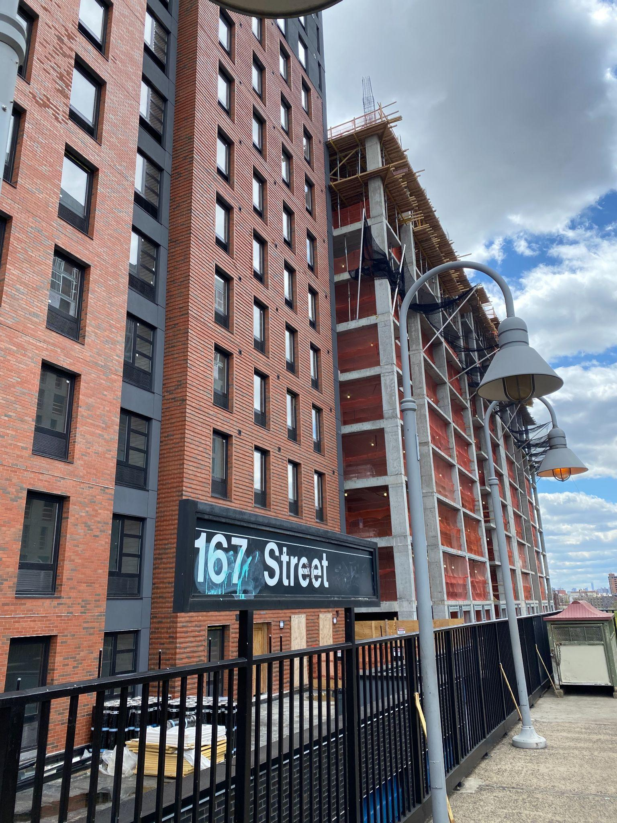
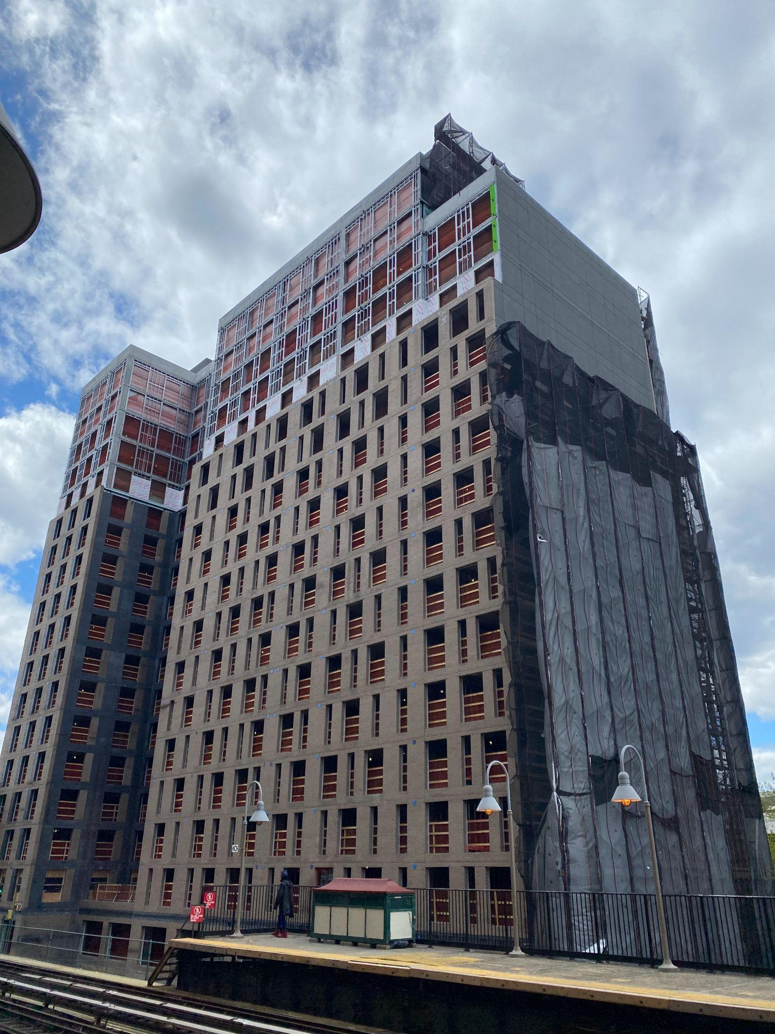
1167 River Avenue and as seen from 167 Street Station.
As seen in recent years, due to higher property values existing landlords are incentivized to take various actions. These include raising their tenants’ rents, with the intent of driving out existing tenants in order to collect higher rents from more lucrative tenants, or selling their buildings, either to other landlords or to developers. In the case of the first scenario, these changes are already seen along the avenue. While there are few vacancies, the ones that are present are quite noticeable, in the midst of an active economic environment. One example is three commercial vacancies along 167th Street and Jerome Avenue, the only stores for rent on the block, suggesting the tenants were pushed out by the landlord.
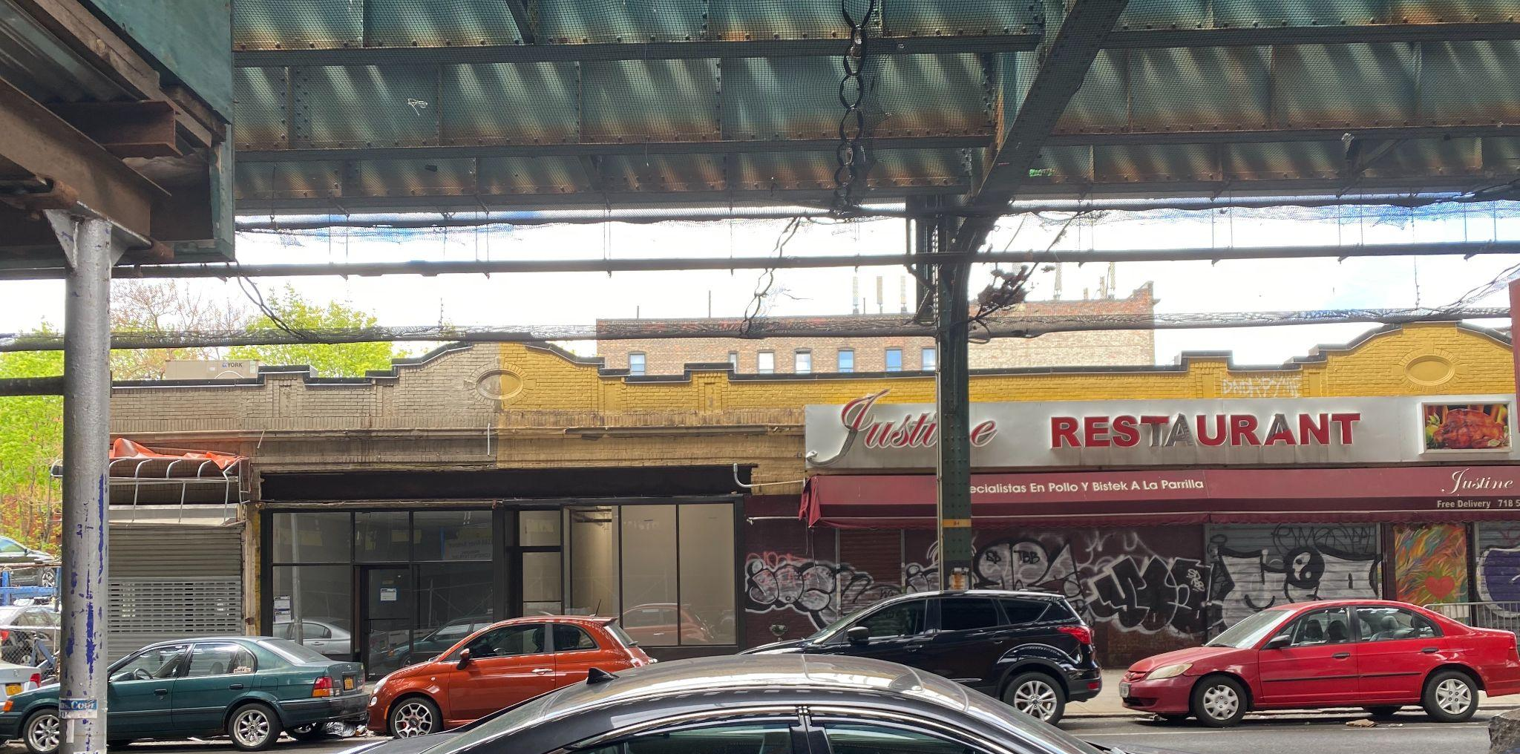
Three vacant commercial spaces on 167th Street and Jerome Ave
Also, as a result of the increased rents at areas of higher foot traffic, it is more likely for chain stores to be present at the heads of stations. In the case of the second scenario, many single story or multi-family houses nearby the avenue, especially in the rezoned blocks along Edward L. Grant Highway, are either listed for sale or in the process of being demolished, presumably to build larger apartment buildings.
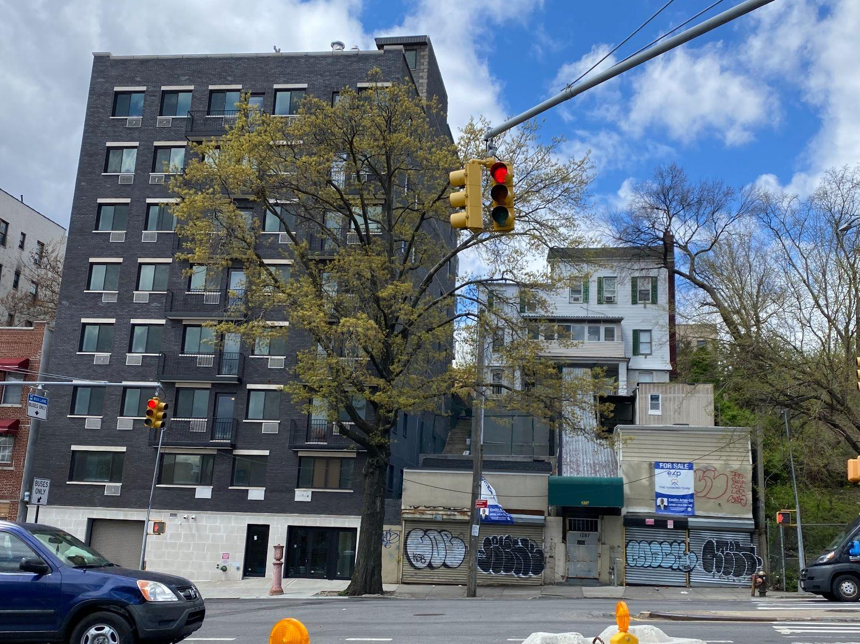
1285 Edward L Grant Highway, a recently built apartment complex for shelter residents, and 1287 Edward L Grant Highway, a 3-story multi-family home listed for sale.
In addition, as mentioned in the book Zoned Out, new construction results in landlords raising the rents of surrounding older buildings, regardless of the amount of affordable housing units. For example, as of 2019, the median rent along the Jerome Avenue rezoning site was $1,177. A newly built apartment complex charging $1800 a month for a one-bedroom would signal to nearby landlords the rent some are willing to pay in the same neighborhood. Consequently, landlords of the older building may choose to raise their rent to $1400, making up the difference because they see the potential for higher profits, and to cover higher property taxes.
A major win of the rezoning, which was not directly passed with the package, however actively pushed for by activists, was the right to counsel legislation passed by New York City Counsel in August of 2018. This law provided residential tenants with a right to legal counsel in the event of an eviction case being brought to them by their landlord. This greatly discouraged the amount of illegal eviction trials brought forth by landlords, and this in combination with the eviction moratorium that went into effect in 2020, helped curb displacement and evictions in the years since. In high-need neighborhoods that initially qualified for the service, evictions decreased by 20% from 2017-2019. Also, 85% of tenants who received legal counsel as a result of the law managed to evade eviction. In addition, the implementation of the worst evictors list helped effectively shame landlords for needless evictions. Another win for activists and tenant organizers was the use of Mandatory Inclusionary Zoning, meaning that all new buildings created would be required to have affordable housing units. In addition, in some cases activists were able to have developers agree to reserve a percentage of units for disadvantaged groups, including the homeless, the elderly, those who live in nearby shelters, those with disabilities and mobility issues, and single-parent households. However, as I will later get into, the promise of affordable housing often falls short.
Community Documentation
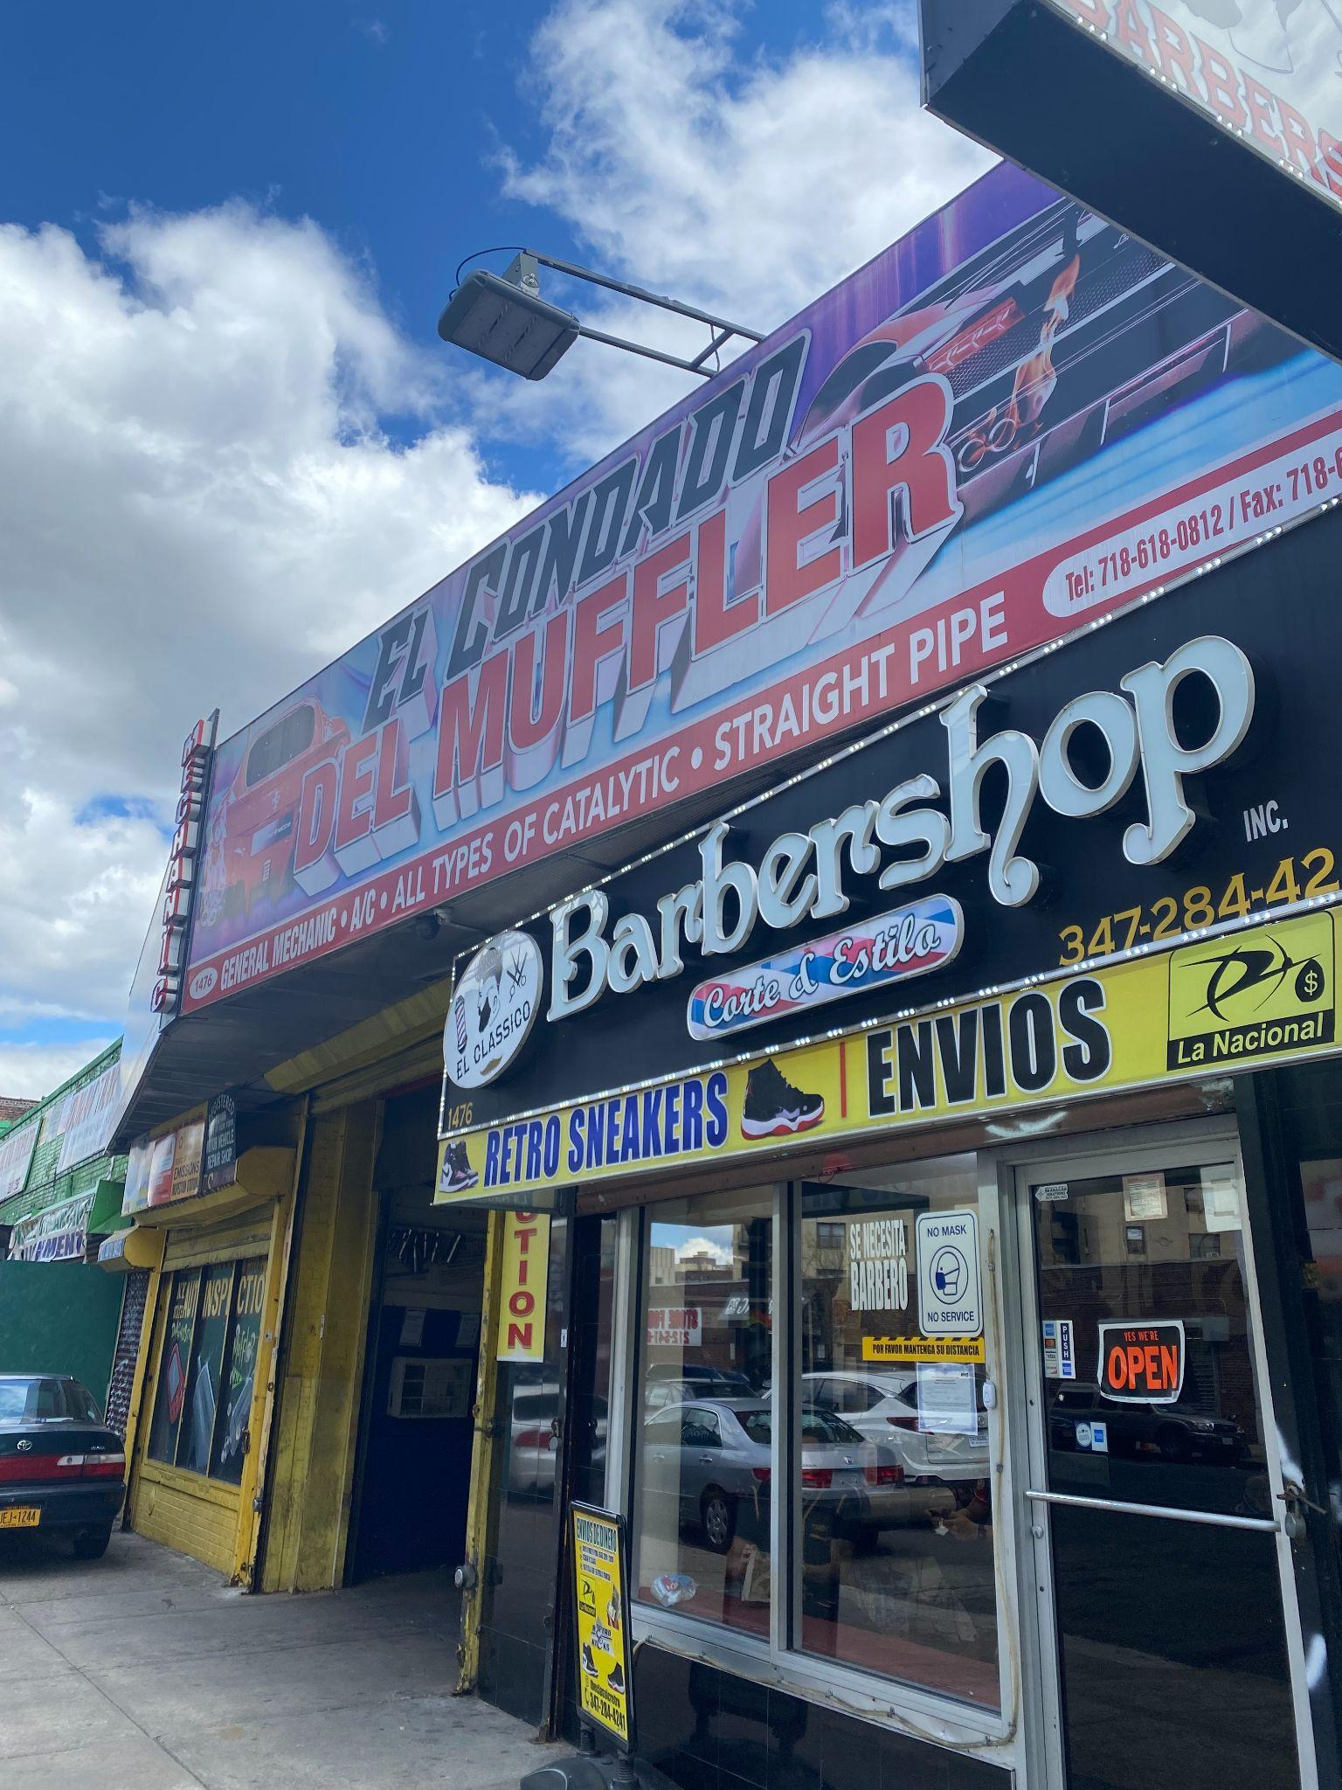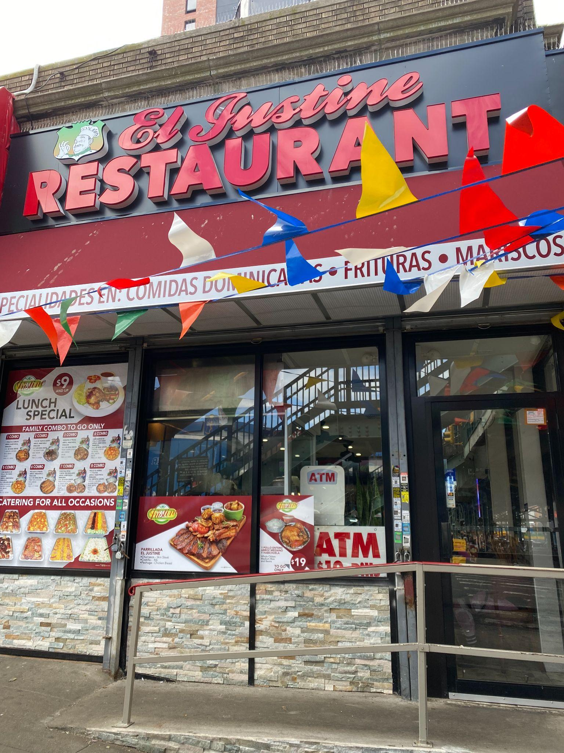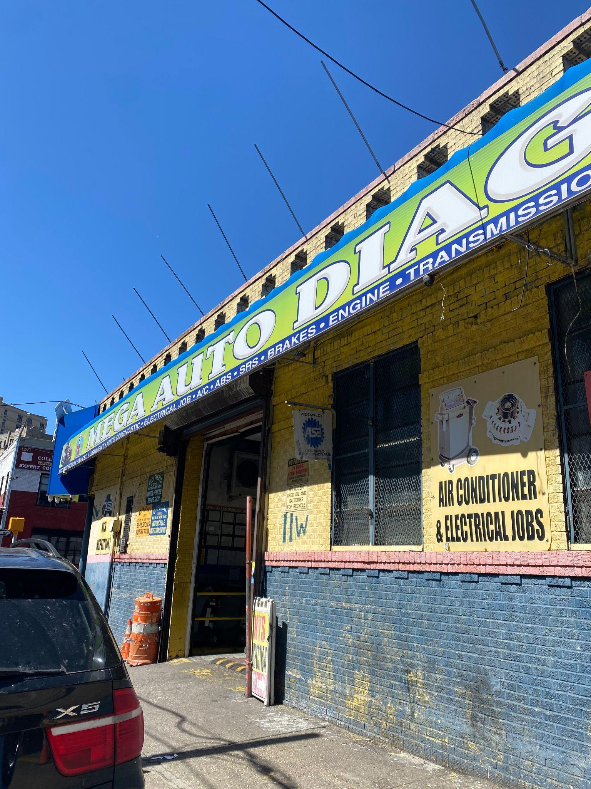
The storefronts of three businesses I visited and spoke with the owners. Left: El Condado Del Muffler (1476 Jerome Ave), Center: El Justine Restaurant (40 E 167th Street), Right: C3R Mega Auto Diagnostics (11 W 169th Street).
I began my community documentation by observing the landscape of Jerome Avenue, and taking photographs of especially notable projects or circumstances. Here, I saw multiple projects under construction, including new apartment buildings, mixed use residential buildings, health facilities, and schools. The commercial vacancies I noticed were either directly at the train stations, or among auto shops along the avenue. During this process, I spoke to stakeholders, including those who are currently working or residing in the area. I asked people on the street if they were residents of the area, about their experiences renting, and if they noticed any changes during their time living in the neighborhood. Some of the main concerns listed among renters included the high cost of rent, which many stated increased despite job losses during the pandemic, and confusion towards housing lotteries of the new buildings in the neighborhood. This aligned with the six major concerns listed by residents of BCB 4 and 5 in the Jerome Avenue Health Plan, which were education, food environment, healthcare quality and access, housing, local economic development, and public outdoor spaces.
I also visited small businesses and asked owners a series of ten questions revolving around their experiences. They also expressed frustration with constant construction, starting early in the morning and extending through the day, contributing to the already heavy noise pollution of the area and traffic congestion. Lastly, they told me about the many changes in the neighborhood in the past decade, including the building of new apartments, schools, and new businesses. These questions included how long they were in business, what a typical day was like for them, how busy they were now versus pre-pandemic, if they owned or rented their space, if they lived in the area, what changes they noticed in the neighborhood, what their biggest challenges were running the business, and lastly how they feel the federal and city government could help. The main concerns listed by small business owners included the current inflation crisis, struggles with making rent, and competition with chains and online businesses. The struggles with paying rent is especially intriguing, as most of the business owners stated the stores were consistently busy, even when compared to pre-pandemic levels. Despite the relative success, the high costs of rent still pose a large challenge to owners and cut into their operational costs and profits.
In response to my last question on government assistance, many businesses stated that they received small business relief funds during the pandemic from the federal government, but no city assistance. These concerns are echoed in a 2021 City Limits article from writers Daniel Parra and Ese Olumhense, which found that $1.5 million of city funds set aside for small businesses affected by the Jerome Avenue rezoning has yet to be received by auto business owners. In addition, Kenneth Brown speaks to these concerns in his experience as District Manager of Bronx Community Board 5. When asked what the government could do to improve their position, business owners stated another stimulus or help with the cost of rent and taxes would be most beneficial.
I also conducted my community documentation by reaching out to key informants involved in various processes of the rezoning. I had the pleasure of speaking with Joan Byron, a longtime Bronx activist and Program Director at the Neighborhoods First Fund. I also spoke with Fernando Tirado, the Director of New Initiatives at the NYC Department of Health and Mental Hygiene. Lastly, I spoke with Kenneth Brown, the current district manager of Bronx Community Board 5. Each key informant gave me a different perspective on the Jerome Avenue Rezoning process, and the interests of stakeholders today. Joan Byron spoke on Bronx activists’ concerns and efforts during city hearings before the rezoning went into effect. In addition, she spoke about the shift of focus in the wake of the passage of the Right to Counsel law, which she cites as a major win on the behalf of tenant organizers. Fernando Tirado spoke on the importance of public health and the role of the Jerome Avenue Public Health Task Force, an organization he was apart of that sought to “address key community health priorities including healthy food access, air quality and environmental health, access to healthcare, and construction mitigation strategies” in the response to the rezoning. Some of these solutions include the building of more community centers, hospitals and health facilities, and greenspaces such as parks. Kenneth Brown spoke about the concerns of business owners and renters in the years since the rezoning, and particularly the unique set of challenges they face as a result of the pandemic. He mentioned several projects the Bronx Community Board 5 intends to work on to help business owners, like offering legal assistance and educational attainment programs.
Policy Solutions
So what options are left for residents and business owners? As seen in other renown New York City rezonings, higher capacity rates on land and real estate speculation overwhelmingly take hold in rezoned neighborhoods. Multiple policy solutions propose protections and alternative options for renters and small business owners.
- MIH Reform - Mandatory inclusionary housing, or otherwise simply referred to as MIH, is a program launched in 2016 borne out of the DeBlasio administration. The goal of the policy is to secure permanent affordable housing in newly built residential buildings by requiring developers to set aside at least 30% of their units for low-income residents. The income levels for affordable housing are determined based on the Area Median Income, which are income levels set by the federal department of Housing and Urban Development. These income levels are often based on a city’s metro area, including nearby affluent suburbs along with the city itself. What results is an overinflated median income that does not reflect the economic realities of many low-income city residents. As of 2022, the New York City AMI for a single person household is $93,400. As mentioned previously, the citywide average median income is $57,000 while the average median income for residents living near Jerome Avenue is $20,000. This creates a large disparity as to who can actually obtain affordable housing units, versus who needs them the most. In the case of Jerome Avenue, some protections do exist to ensure that affordable units in newly built buildings go to local residents. For example, law requires at least 50% of affordable housing units built under MIH go to residents living within the community district. In addition, an essential part of the Uniform Land Use Review Procedure (ULURP) process that every developer has to go through is a hearing by the district’s community board. During these hearings, concerns are raised by locals and members of the board, often leading to important concessions made by the developers. This at least ensures that representatives of the community have a say in the process, however still requires strong negotiating with private developers that can be avoided somewhat if important reforms to MIH were made. First and foremost, one of the most important changes to the current MIH system would be a change in how AMI is calculated. Being confronted with the requirements for affordable housing is often a major shock to those who need it, and for these high income requirements to be present in housing, but not present in other social welfare programs like WIC is unfair. AMI should be calculated at a more localized level, preferably by community district. This would make the most sense in New York City, as community districts are a unique and unchanging feature of the city’s geopolitical landscape, unlike congressional districts and state senate districts. In addition, community districts are grouped by generally related neighborhoods, meaning it is more likely for residents to move within their community district when applying for affordable housing units. A localized approach to AMI would allow for the city’s poorest and most in-need residents to obtain housing through the lotteries, rather than being an empty promise and prospect that is unattainable. Along with this change to how AMI is calculated, there should be leniency on the income requirements for apartment units. Oftentimes, applicants find themselves disqualified from obtaining a unit because they make a few dollars over the income requirement. This leaves out many residents from the process, and disincentivizes those not chosen in the housing lotteries from going through the process again. Another reform to MIH that would benefit residents of Jerome Avenue is requiring developers to set aside a higher number of units to affordable housing, and to require those units go to those who are on the lower spectrum of the area median income. When looking at recently opened housing lotteries for buildings along Jerome Avenue, the issue with the non-specificity of MIH policy becomes apparent. In a housing lottery notice posted in November of 2021 for 1769 Jerome Avenue, about 35% of the 16-story mixed-use buildings’ units were designated for affordable housing. Out of 175 units, 60 units were available through the Housing Connect lottery. Of these 60 affordable units, 35 units were available to those making 60% of the AMI, and 25 were available to those making 80% of the AMI, a range of eligible incomes from $34,972 to $118,400. While the most amount of units available were for those at the lower end of the AMI, the lowest income level is still $14,000 higher than the median income of Bronx Community Districts 4 and 5. In addition, the more space in a unit, the higher the eligible income level must be. This excludes the needs of low-income families and single-parents who may need the space of a 1 or 2 bedroom, however may only be eligible for a studio apartment. In another housing lottery posted in May of 2021 for 1325 Jerome Avenue, a 21-story mixed use building, 101 units were available through Housing Connect. The eligible incomes ranged from $25,200 to $88,800, for residents making between 40-60% of the AMI. However, unlike the previous lottery, the most amount of units were reserved for those making the higher percentage of the AMI. 68 units were reserved for those making 60% of the AMI, 13 units were reserved for 50% of the AMI, and only 8 units were reserved for those making 40% of the AMI. Numerically, the residents most likely to need affordable housing making the least amount of the AMI were left to compete for a small amount of units. The best way to benefit residents most in need would be to increase the amount of units designated for affordable housing from 30% to 50%, along with making the distribution of units scaled so that the most units go towards those making the lowest percentage of the AMI. Like buildings being created in the Inwood Rezoning area, more of these multi-story buildings should be entirely affordable housing. For example, in the case of the 30-story apartment complex Sherman Creek North Cove currently in development along 207th Street, all 611 units will be set aside for affordable housing. More complexes like these are being built in the Jerome Avenue rezoning area, such as the proposed River Commons along 168th Street and River Avenue. This complex, revealed by HPD in January 2022, will hold 278 affordable units altogether, along with community centers on the ground floors that will be occupied by BronxWorks, a community support organization focused on assisting residents with housing, childcare, and emergency assistance, and the African Resource Center, which seeks to provide similar services for the growing ethnic enclave. More measures like this would better secure housing without displacement for low-income residents.
- 421a tax break repeal - 421a is a tax break established in New York City in the 1970s. First implemented in 1971, the 421a tax break was passed by New York City Council with the intention of incentivizing developers to build within the city. This was during an era in which suburbanization and urban decay left New York with a lack of housing, especially quality housing. In essence, the tax break allows developers to build more stories over the zoning limits, if they designate a portion of built residential units to be affordable housing or a public plaza. Initially, the tax program was not touted as an affordable housing measure, but rather to motivate developers to build at a lower cost within the city. However, in the decades since, affordability requirements have been added in order to continue the program and improve its image with the public. However, unlike MIH, affordable units built under 421a are not required to be affordable long-term. Affordability requirements are set by the developers, and can be revoked at their discretion or after a certain period. In addition, 421a buildings are oftentimes located in rapidly gentrifying neighborhoods, and marketed as luxury units with luxury rents, usually far beyond the market rate. A major issue with this tax program is the fact that history shows developers do not hold up to their promises, getting to build luxury towers at a discount without providing enough affordable units. Said affordable units are typically offered to households at higher ends of the area median income, with some income requirements being 80% of the AMI, starting at around $100,000 per year. This high level leaves out many New York City residents, especially those in the Jerome Avenue rezoning area. Developers have come to rely on this tax break, often factoring it into their building costs and long-term profits. As a result, its continuance persists, essentially acting as a handout to developers while doing little to substantially provide more affordable housing. With its renewal on the table this year, the 421a tax break should be repealed altogether, with those funds being put towards other affordable housing measures like MIH, section 8 vouchers, and public housing.
- Community land trusts - Community land trusts are a smaller scale alternative that seeks to put land ownership in the hands of renters. In their most basic form, CLT’s are non-profit organizations that hold and own land on behalf of a community. From there, the non-profit allows local residents to develop the land to their desires. Typically, this includes permanent affordable housing, commercial units, community centers, and community gardens. These sites seek to empower residents plagued by the trials of renting by putting ownership into their own hands, and not leaving them beholden to a constantly changing market. A longstanding CLT success story in New York City is the Cooper Square CLT, established in 1991 in the East Village, and currently housing hundreds of low-income residents and 22 small business owners with nominal rents. Starting in 2019, New York City has allocated funds for CLT’s across the five boroughs as a part of the yearly city budget. In 2021, $1.5 million was dedicated to funding CLT’s and activists are looking to double that number to $3 million in 2022. In the wake of the passage of the Right to Counsel Law, the larger priorities of tenant organizers shifted towards CLT’s as a way to evade the market, now that such a major renter’s right had been secured. Currently, a Bronx-based activist organization is working to establish a community land trust within the borough. Founded in 1974, the Northwest Bronx Community Coalition and Clergy is an organization focused on securing housing rights for residents of the Northwest Bronx. In January of 2020, the NWBCCC formally incorporated the Bronx Community Land Trust, the first step needed to organize a CLT and develop a site owned and operated by its residents. The NWBCCC intends on receiving land for the CLT from the city directly, free of charge. In their 2020 report “Fighting Forward: Advancing Development without Displacement through Community Land Trusts, Shared Governance, and Collective Ownership”, the organization identifies 26 vacant or underutilized city-owned sites that could operate as a CLT. Once built, the Bronx CLT would exist as a shared community space with housing and a neighborhood center, fully owned and operated by its residents. Two sites in the NWBCCC’s report are near the Jerome Avenue rezoning area, leaving residents affected to potentially benefit from the project.
- Vacancy taxes - A recommendation often cited in the political sphere is the use of vacancy taxes. Vacancy taxes would be placed on either commercial or residential units that remain empty for long periods of time, ideally a year or more. Such a policy is especially needed in New York City, where nearly 80% of vacant land is commercial spaces. In commercial corridors, vacant units leave a missed opportunity for increased economic activity and community exchange. In the case of upzonings, when left with a vacant commercial unit, landlords will often purposely leave the unit vacant, in hopes of nabbing a tenant willing to pay a massively hiked up rent. As previously mentioned from observation around the neighborhood, the majority of chain businesses are located at the mouths of the train stations. This is most likely due to the fact that rents are higher where the most foot traffic occurs, thus leaving chain stores as the only tenants better able to pay inflated rents. Another possible concern towards increased amounts of vacant commercial units is the reduction of “eyes on the street”. The less commercial activity in an area, the less foot traffic and people frequenting a region. Research has shown that in areas that experienced large amounts of business evictions and vacancies, crime rates increased. In January of 2019, New York State Senator Robert Jackson introduced a vacancy tax bill into the senate, which is currently in committee. This bill proposes a 1% tax on the property value of a vacant commercial unit in a city of 1 million or more residents, if the unit has been vacant for more than a year. Such a tax would cut into the profit margins of landlords and developers, and ideally motivate landlords to lease their vacant commercial spaces at lower rents. This would leave room for smaller businesses to occupy storefronts along the avenue, especially along heavily trafficked areas.
- Commercial rent control - An often overlooked idea, commercial rent control actually has a storied history within New York City. In order to fuel economic development in the postwar years, New York State legislators came up with a solution for struggling business owners. From 1945 to 1963, commercial rent control was in place across New York State. This policy put a cap on the amount of rent commercial renters were charged, allowing for thousands of small business owners to grow their operations without the standard economic pressure of making rent. As recently as September 2021, a bill proposing commercial rent control was introduced by Brooklyn councilman Stephen Levin into New York City Council. Currently, between leases commercial rents can increase as high as 100-300% without warning. Businesses that were once viable, or struggling to make rent already, are left with no choice but to close. Along with commercial rent control, other potential solutions are being considered by business owners along Jerome Avenue. According to Kenneth Brown, after issues faced during the pandemic, owners are looking into forming a business improvement district for Jerome Avenue to address their needs and better negotiate with landlords. With little help received from the city following the pandemic and the rezoning, the structure of a BID would embolden small business owners to establish rights amongst themselves. In addition, Brown placed a large emphasis on the need for legal counseling. Many business owners, especially those in the auto shops along Jerome, do not speak English, or speak it as a second language. In addition, some business owners may not keep formal bookkeeping and track of finances. Many do not have a formal lease agreement, as stated by Kenneth Brown. When negotiating with landlords and the legal system, this leaves owners without necessary safeguards. Another possible benefit to commercial rent control is the benefit that comes with prosperity when running a small business. Owners would be able to better maintain and expand their businesses, further boosting economic activity in the corridor.
Conclusion:
Overall, the Jerome Avenue Rezoning so far has been a mixed bag of results, leaving longtime residents and business owners with more to lose rather than to gain from changes to the urban landscape. Despite this, major wins like the right to counsel law have been passed, further strengthening tenants’ rights in New York City. Policy wise, there is still a long way to go in the right to secure affordable housing for low-income New Yorkers, in a way that discourages displacement and real estate speculation. Ideally, a mix of all the outlined policy recommendations would provide the most benefits to those negatively affected by the Jerome Avenue rezoning. A reform to Mandatory Inclusionary Housing policy, including a more localized approach to how area median income is calculated, would allow units in new buildings to go to residents in the most amount of need. The repeal of the 421a tax program would incentivize developers to build housing for the sake of profit, with hopefully less luxury developments with rents offered at beyond the market rate, with limited and impermanent affordable units. The successful implementation of community land trusts in the Bronx would benefit a small number of residents, however allow those residents to be in control of their own housing, and also serve as an important example to tenants and community organizers citywide. The imposition of a vacancy tax on commercial units would motivate landlords to rent out units at lower rates rather than holding out for the highest paying tenant. Lastly, the establishment of commercial rent control policy would protect small business owners from massive rent hikes in-between leases, and allow them to grow and expand their operations, further contributing to economic activity along Jerome Avenue.
Rezonings contain the potential to do good for low-income communities, through the creation of housing, schools, parks, and other locations that contribute to social reproduction and a better quality of life. However, safeguards must be put in place by New York City in order to protect people’s livelihoods and ways of life. More concessions must be made to create projects from rezonings that contribute to the public good. Well-maintained and safe parks, good schools, and quality housing are cornerstones to residents of Jerome Avenue, ones that they hope to see created in years to come. In addition, the city must work to bridge the income gap between its richest and poorest residents. For residents of Bronx Community Boards 4 and 5, this can be achieved through educational attainment programs, vocational training, and employment programs aimed to get residents into higher paying jobs, ensuring that they have the means to afford increasing costs of living.
All in all, Jerome Avenue is a vibrant commercial corridor, home to hundreds of small businesses integral to the lives of surrounding residents and merchants. While the environment is ever changing, these policies help to see a future that keeps the majority in mind, and gives an opportunity for New York City to prove its duty to the millions of residents who call it home.
Reference List
Angotti, T. (2007). Community Land Trusts and Low-Income Multifamily Rental Housing: The Case of Cooper Square, New York City. Lincoln Institute of Land Policy, 1–24. Retrieved from https://www.lincolninst.edu/sites/default/files/pubfiles/angotti-wp07ta1.pdf.
Angotti, T. (2017). Zoned out!: Race, displacement, and City Planning in New York City. Terreform.
Churches United For Fair Housing. (2019). Zoning and Racialized Displacement in NYC. Retrieved from https://static1.squarespace.com/static/5dc0429de5717c7ff1caead0/t/5de6c0e683bec649d37ab0cc/1575403753814/Zoning+and+Racialized+Displacement+in+NYC.pdf.
City Limits. (2016, December 21). ULURP Explained. Retrieved from https://citylimits.org/zonein/ulurp-explained/.
Conde, E. G. (2022, April 29). Apply for brand new apartments as low as $588/mo for 2 bedrooms near Yankee Stadium. Welcome2TheBronx. Retrieved from https://www.welcome2thebronx.com/2022/04/29/apply-for-brand-new-apartments-as-low-as-588-mo-for-2-bedrooms-near-yankee-stadium/.
David, G. (2021, September 16). New York City Commercial Rent Control Push Plays Out Under Pandemic Shadow. The City. Retrieved from https://www.thecity.nyc/2021/9/15/22676539/new-york-city-commercial-rent-control-bid
Davis, J. (2020, May 7). Rezoning Jerome Avenue: Examining Geographies of Displacement. Conflict Urbanism, Spring 2020. Retrieved from https://centerforspatialresearch.github.io/conflict_urbanism_sp2020/2020/05/07/davis.html.
Dikanovic, A. (2022, March 9). NYC Tenants’ ‘Right to Counsel’ Expands Citywide. Here’s Why that’s a Big Deal. The City. https://www.thecity.nyc/2021/5/20/22444023/right-to-counsel-expands-citywide-why-thats-a-big-deal-tenants-nyc#.
Hagen, B. (2021, August 10). VICTORY! Community Land Trusts Win Major Funding in NYC Budget. New Economy Project. Retrieved from https://www.neweconomynyc.org/2021/08/victory-clt-funding/.
Hughes, C. J. (2021, September 10). Inwood watches closely as new zoning kicks in. The New York Times. Retrieved from https://www.nytimes.com/2021/09/10/realestate/inwood-manhattan-new-zoning.html.
Jackson, R. (2022, January 6). NY State Senate Bill S2005. NY State Senate. Retrieved from https://www.nysenate.gov/legislation/bills/2021/S2005#.
Jerome Avenue Public Health Task Force. (2020, October). Jerome Neighborhood Health Plan Recommendations for Bronx Community Districts 4 and 5.
Keating, W. D. (1985). The Elmwood Experiment: The Use of Commercial Rent Stabilization to Preserve a Diverse Neighborhood Shopping District. Journal of Urban and Contemporary Law, 28(107), 124–136. Retrieved from https://journals.library.wustl.edu/urbanlaw/article/8343/galley/25176/view/.
Kully, S. A. (2020, March 4). De Blasio Admin. says there'll be no Southern Boulevard rezoning. City Limits. Retrieved from https://citylimits.org/2020/02/28/de-blasio-admin-says-therell-be-no-southern-boulevard-rezoning/.
Londono, V. (2021a, May 16). Affordable Housing Lottery Launches for 1325 Jerome Avenue in Mount Eden, The Bronx. New York YIMBY. Retrieved from https://newyorkyimby.com/2021/05/affordable-housing-lottery-launches-for-1325-jerome-avenue-in-mount-eden-the-bronx.html.
Londono, V. (2021b, November 25). Housing Lottery Launches for 1769 Jerome Avenue in Morris Heights, The Bronx. New York YIMBY. Retrieved from https://newyorkyimby.com/2021/11/housing-lottery-launches-for-1769-jerome-avenue-in-morris-heights-the-bronx.html.
Morris, S. (2022, January 13). HPD reveals River Commons affordable housing property in Concourse, the Bronx. New York YIMBY. Retrieved from https://newyorkyimby.com/2022/01/hpd-reveals-river-commons-affordable-housing-property-in-concourse-the-bronx.html.
Moszkowski, E. (2022, April 8). Can Retail Vacancy Taxes Reduce Storefront Vacancies? Joint Center for Housing Studies. Retrieved from https://www.jchs.harvard.edu/calendar/can-retail-vacancy-taxes-reduce-storefront-vacancies.
NYC Department of City Planning. (2018a). Bronx Community District 4 - NYC Community District Profiles. NYC Community District Profiles. Retrieved from https://communityprofiles.planning.nyc.gov/bronx/4.
NYC Department of City Planning. (2018b). Bronx Community District 5 - NYC Community District Profiles. NYC Community District Profiles. Retrieved from https://communityprofiles.planning.nyc.gov/bronx/5.
NYC Department of City Planning. (2021, December 22). Jerome Avenue Neighborhood Plan. Jerome Avenue Neighborhood Plan - DCP. Retrieved from https://www1.nyc.gov/site/planning/plans/jerome-ave/jerome-ave.page.
NYC Department of City Planning. (2016). Mandatory Inclusionary Housing- DCP. NYC Planning. Retrieved from https://www1.nyc.gov/site/planning/plans/mih/mandatory-inclusionary-housing.page.
NYC Department of City Planning. (2017a). Commercial Districts: C4. NYC Planning. Retrieved from https://www1.nyc.gov/site/planning/zoning/districts-tools/c4.page.
NYC Department of City Planning. (2017b). Residence Districts. NYC Planning. Retrieved from https://www1.nyc.gov/site/planning/zoning/districts-tools/residence-districts-r1-r10.page.
New York City Department of Housing Preservation and Development. (2022). Area Median Income - HPD. NYC HPD. Retrieved from https://www1.nyc.gov/site/hpd/services-and-information/area-median-income.page.
Northwest Bronx Community Coalition and Clergy. (2020). Fighting Forward: Advancing Development Without Displacement Through Community Land Trusts, Shared Governance and Collective Ownership. NWBCCC. Retrieved from https://online.fliphtml5.com/tjlfe/wzlz/#p=1.
Parra, D., & Olumhense, E. (2021, November 29). 3 years after Bronx rezoning, Jerome Avenue Auto Shops under pressure. City Limits. Retrieved from https://citylimits.org/2021/10/20/3-years-after-bronx-rezoning-jerome-avenue-auto-shops-under-pressure/.
Pratt Center for Community Development. (2020). Our Hidden Treasure: Recovering Land Value to Repair and Rebuild. Pratt Center. Retrieved from https://prattcenter.net/our_work/our_hidden_treasure.
Stein, S. (2017). Progress for whom, toward what? Progressive politics and New York City’s Mandatory Inclusionary Inclusionary Housing. Journal of Urban Affairs, 1-12. https://doi.org/10.1080/07352166.2017.1403854.
Take Root Justice, & Right to Counsel - NYC Coalition. (2022, March). Organizing is Different Now. Retrieved from https://takerootjustice.org/wp-content/uploads/2022/03/Organizing-is-Different-Now-0322.pdf.
U.S. Census Bureau. (2019). SE:A18009. Median Gross Rent. 2014-2019 American Community Survey 5-Year Estimates. Retrieved from Social Explorer.
U.S. Census Bureau. (2019). SE:A00001. Total Population. 2014-2019 American Community Survey 5-Year Estimates. Retrieved from Social Explorer.

Kully (2020).
NYC Dept of City Planning (2021).
Hughes (2021).
Morris (2022).
Churches United For Fair Housing (2019).
Churches United For Fair Housing (2019).
New York City Department of Housing Preservation and Development (2022).
NYC Department of City Planning (2016).
U.S. Census Bureau (2019).
NYC Planning (2018a), NYC Planning (2018b).
NYC Department of City Planning (2018a), NYC Department of City Planning (2018b).
NYC Department of City Planning (2016), NYC Department of City Planning (2021).
NYC Department of City Planning (2021).
NYC Department of City Planning (2021).
NYC Department of City Planning, (2017b).
NYC Department of City Planning, (2017a).
Stein (2017).
Stein (2017).
​​Davis (2020).
Angotti (2017).
Angotti (2017).
Dikanovic (2022).
NYC Department of City Planning (2021).
Morris (2022), Conde (2022).
Stein (2017).
NYC Planning (2018a), NYC Planning (2018b)
NYC Department of City Planning (2016)
Stein, 2017.
City Limits (2016)
Londono (2021b).
NYC Planning (2018a), NYC Planning (2018b).
Londono (2021a).
​​Haag & Zaveri (2022), Stein, 2017.
Stein (2017), Angotti (2017).
Churches United for Fair Housing (2019).
Haag & Zaveri (2022).
Northwest Bronx Community Coalition and Clergy (2020).
Pratt Center for Community Development (2020).
Parra & Olumhense (2021).
Parra & Olumhense (2021)
Jackson (2022).
Hagen (2021).
Angotti (2007).
Parra & Olumhense (2021).
Moszkowski (2022).
Moszkowski (2022).
Keating (1985).
David (2021).
Jerome Avenue Public Health Task Force (2020)
Jerome Avenue Public Health Taskforce (2020).
Take Root Justice, & Right to Counsel NYC Coalition (2022).
Hughes (2021).

